**AWS SQS (Simple Queue Service)**

It is a **Fully managed message queuing service** by AWS.

Allows applications/microservices to **communicate asynchronously** by passing messages through a queue.

You don’t need to manage servers or message brokers – AWS handles scaling, availability, and reliability.

**How it works**

1. A **producer** application sends (publishes) a message to the **queue**.
2. The message stays in the queue until a **consumer** application retrieves it.
3. Once processed, the consumer deletes the message from the queue.This ensures **decoupling** – producers and consumers don’t need to run at the same time.

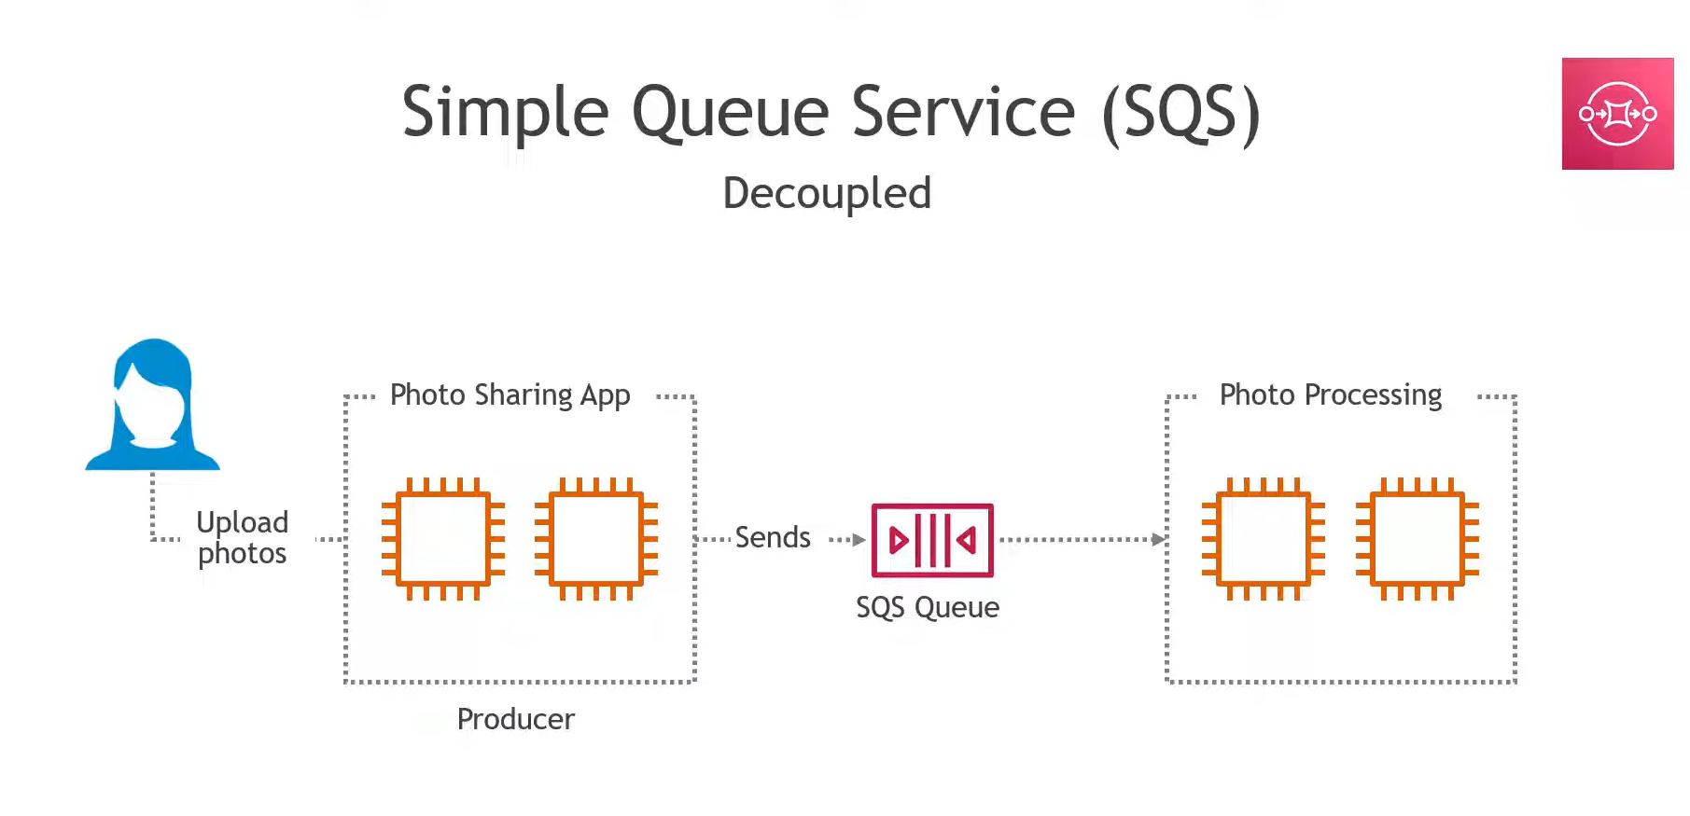

### Types of SQS

1. **Standard Queue**
   * Unlimited throughput.
   * Messages may be delivered more than once (at-least-once delivery).
   * Order is not guaranteed.
2. **FIFO Queue (First In, First Out)**
   * Strict order (first in, first out).
   * Exactly-once processing.
   * Limited throughput compared to Standard queues.

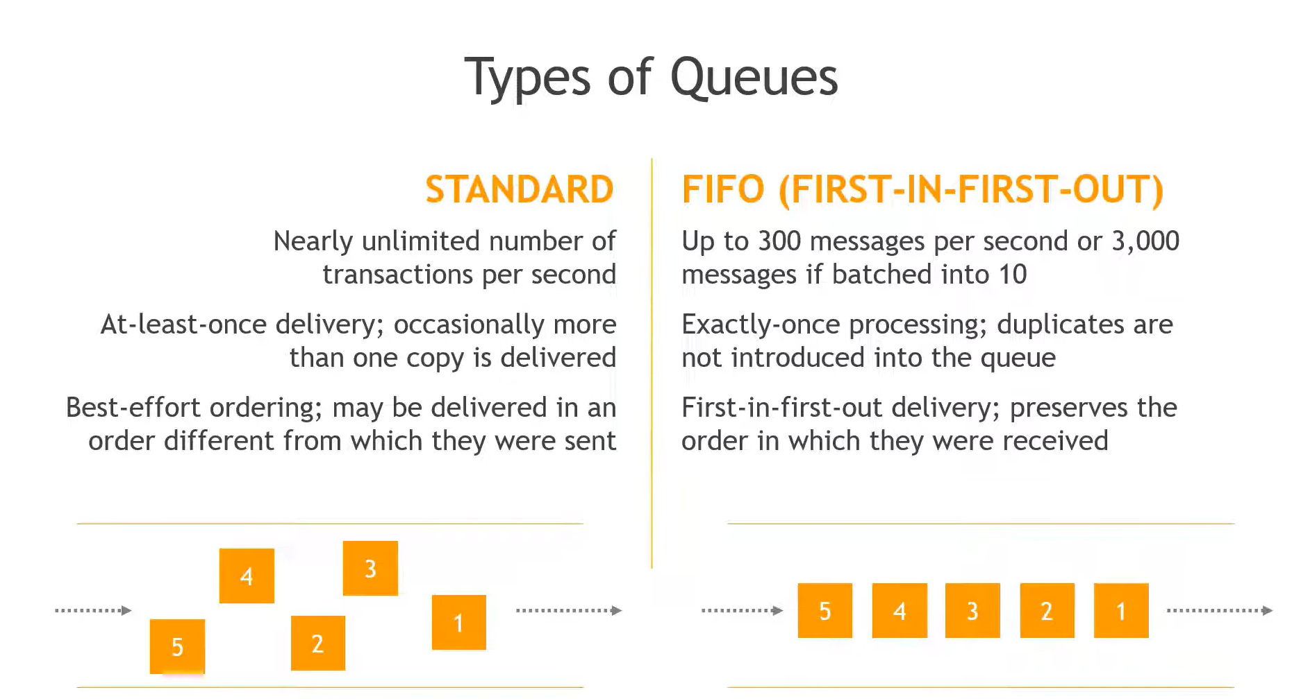

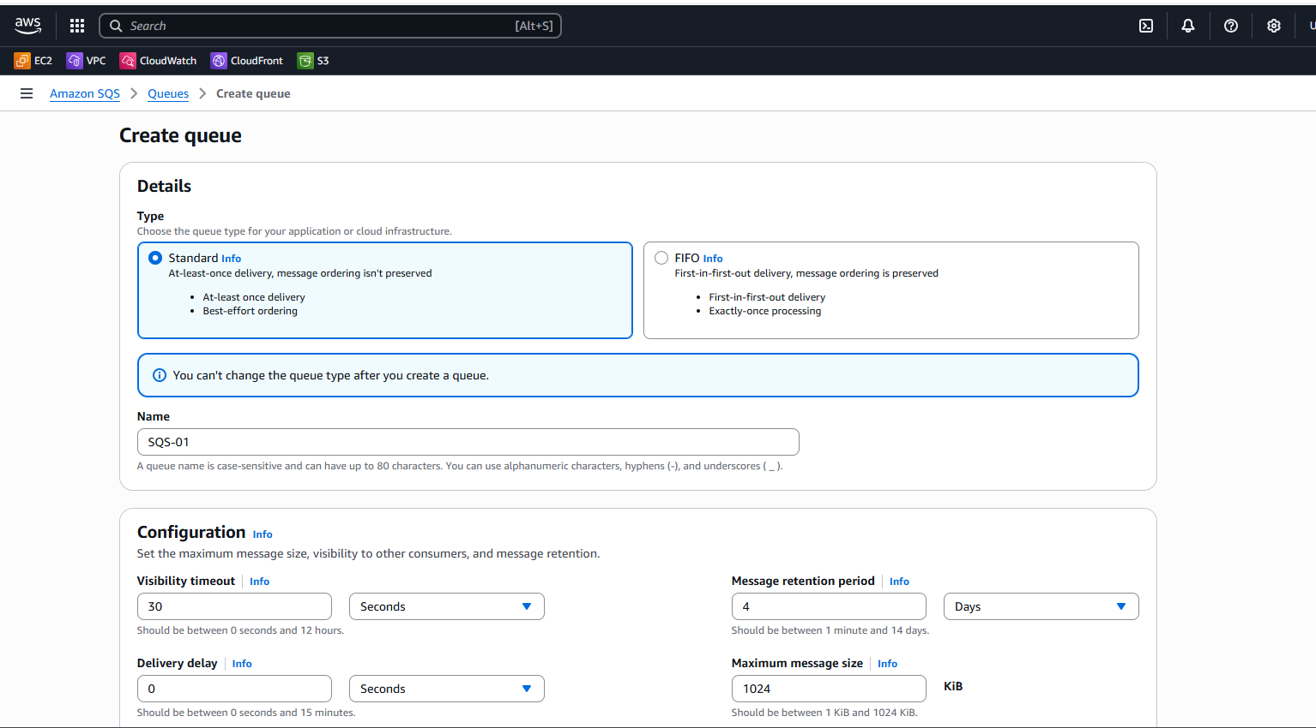

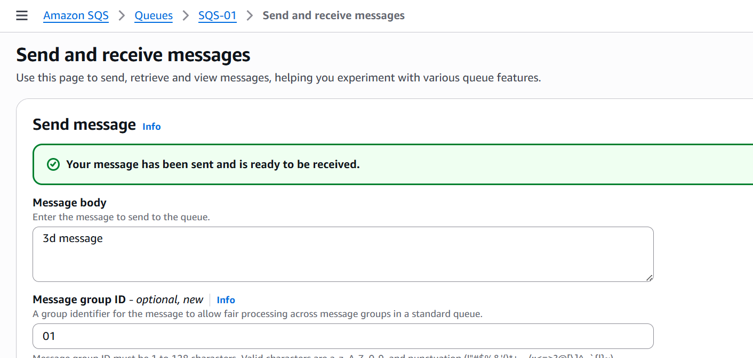



# 2. Amazon MQ

* A **managed message broker service** that supports **industry-standard protocols** like:
  + **AMQP, MQTT, OpenWire, STOMP**.
* Based on popular open-source brokers: **Apache ActiveMQ** and **RabbitMQ**.
* Unlike SQS, which is AWS-native, **Amazon MQ is for users who need traditional messaging protocols** to connect with existing systems.

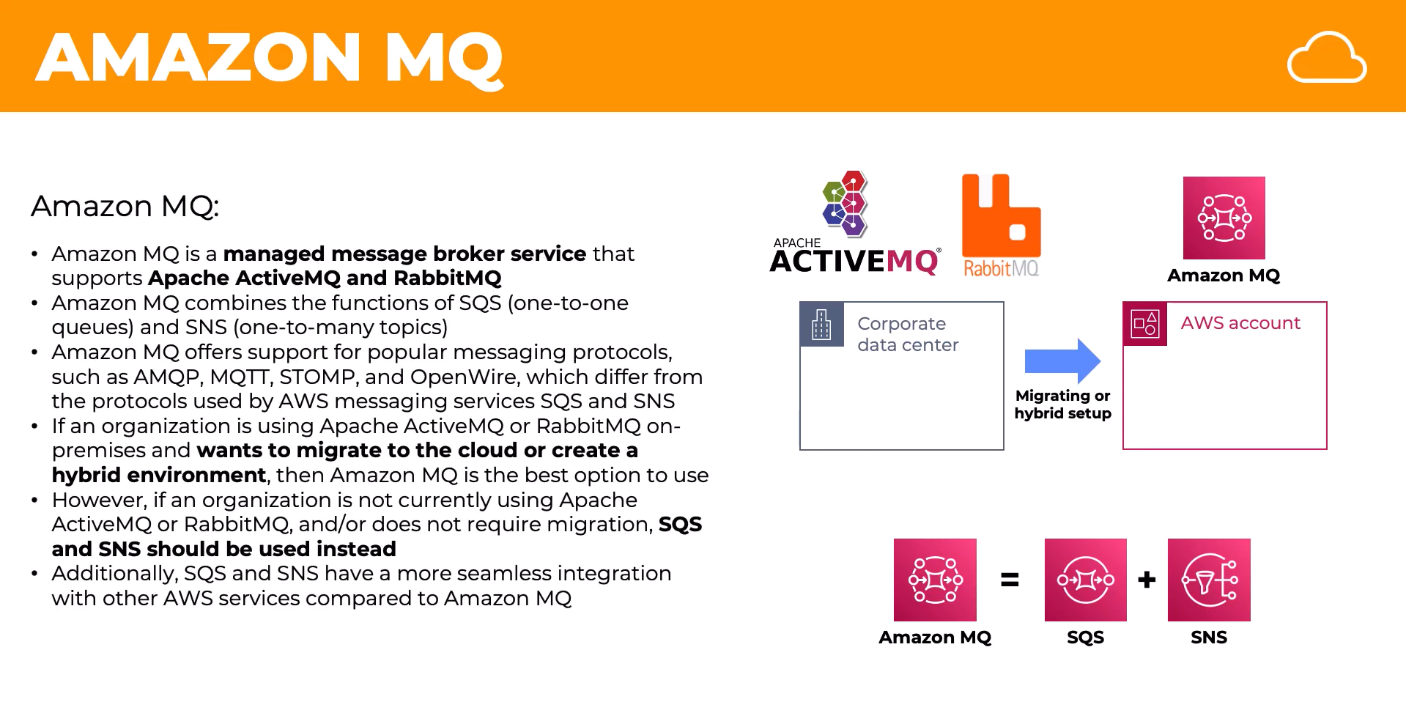

### How it works

1. AWS provisions a managed **ActiveMQ/RabbitMQ broker** for you.
2. Producers and consumers connect via industry-standard protocols.
3. Messages can be routed using **topics, queues, fanout exchanges, direct exchanges** (depending on broker type).
4. Supports advanced features like **durable subscriptions, message priorities, transactions**.

### Real-time Example of Amazon MQ

**Banking Transaction System**

* Banks often use **JMS (Java Message Service)** or **AMQP** for communication.
* Suppose a banking app needs to:
  + Send a transaction request → **Producer sends message to MQ**.
  + Fraud detection system, Accounting system, Notification system → all consume it.
* Amazon MQ is better than SQS here because it supports **protocol compatibility** and advanced messaging patterns.